***Adventure Guides Compass Pin***

***Program***

***___________________***

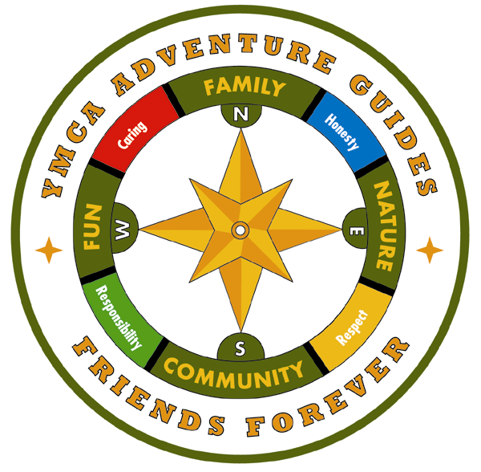

Program Theme

Program Compass

“This compass is used as a tool to navigate the journey.”

This program is based on the adventures of a parent and child and of their Circles and Expeditions. This program gives members a sense of direction and an inspiration for activities. The four main direction points are the essential components of the program.

Directions

1. The Family is True North – the focal point of the program
2. Nature and the camping experience are an integral part of the program
3. The spirit of the program is experienced through belonging to a small Community called a circle
4. Fun is the magic of the program
5. The YMCA core values provide direction as parents guide children on their journey

The YMCA Core Values make up the other directional points. Along the journey, adults should model, teach and demonstrate these values as well as give children many opportunities to practice and celebrate them. Initially, these four values provide guidance in helping children select activities, make decisions, and choose appropriate courses of action - both in the program and in their lives.

Core Values

* Caring
* Honesty
* Respect
* Responsibility

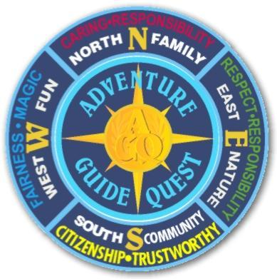

Compass Program”.

1. Four Journeys; North, East, South, and West
2. Children will receive a “Base” patch.
3. As each Journey is completed they will receive the specific quadrant rocker, until the circle is complete.

________________________________________

Compass Program Legend

Red - Parent and child activities

Blue - Circle activities

Green - Expedition activities

**First Journey - North**

* Know the Names! * *
  + The parent and child will learn and recite the Adventure names of all children for the Circle.
* Seven Aims * * *
  + The parent and child will learn and recite the Seven Aims for the Circle.
* Good Conduct *
  + The child will be acknowledged for good conduct, by the Circle leadership, at three consecutive meetings.
* Mom’s Night Off * * *
  + Arrange for Mom to have a night off. The parent and child will plan, purchase, cook and serve dinner (MOM SHOULD NOT BE ALLOWED IN THE KITCHEN). After serving dinner, the parent and child will do the dishes. Have Mom write a statement that will be presented by the child to the Circle.
* Parent/Child Camping Trip * *
  + The parent and child will go on a camping trip, for at least one night, and prepare their own food. This can be done alone or with the Circle.
* Three Arts & Crafts * * *
  + The parent and child will do three arts & crafts representing the theme of their Circle and their Adventure Guide names.

Second Journey - East

* Grow, Grow, Grow! * *
  + The parent and child are to plant/grow a vegetable/fruit and present their crop to the Circle.
* Two-Mile Hike * * *
  + The parent and child are to take a two-mile hike and report to their Circle on any interesting sights or events on this trip.
* Athletics:
  + Option A * * *
    - 2 pushups
    - 5 sit-ups
    - jog a 1/4 of a mile
  + Option B * * *
    - Swim 25 feet
    - Retrieve an object that is underwater
    - Tread water or float for two minutes
* Family Tree * *
  + The parent and child are to research, create, and present a Family Tree that goes back at least two generations. This Family Tree should incorporate photos and represent all nationalities found in their research.
* Endangered Species *
  + The parent and child are to research, write, and present a report, to their Circle, on five endangered species that can be found in their local area.
* Photo-scrapbook *
  + The parent and child are to create, and present a photo scrapbook of any event that they have attended, to the Circle. Best if the child takes the pictures.

**Third Journey - South**

* Animal Tracks * * *
  + The parent and child will draw, identify and present to the Circle three animal tracks. The tracks must have been seen.
* National Park *
  + The parent and child are to research, create, and present a report on a National Park. A park that was visited by the child is recommended, but not required.
* Special Trip * * *
  + The parent and child will take a special trip (overnight is recommended but not required) and report back to the Circle of any special happenings.
* Geology *
  + The parent and child must collect, identify and display to the circle, a collection of ten rocks, gems and/or minerals.
* Meteorology * * *
  + The parent and child must identify and display three different cloud formations. They must also be able to explain why each cloud formation occurs and the type of weather each formation represents.
* Reverse role-playing
  + Option A: * * *
    - The parent and child are to reverse roles for one day (a minimum of four hours) and report their fun findings to the Circle.
  + Option B: *
    - The child will spend part of the day with the parent at work and report their experience to their Circle.

**Fourth Journey - West**

* Stilts * *
  + The parent and child will build a pair of stilts. Under the supervision and guidance of the parent, the child will do all the measuring, cutting, sanding and fastening. The parent and child will present the stilts to their Circle.
* Knife safety * * *
  + The parent will demonstrate the proper and safe way to use a knife to the child. After the child demonstrates proper and safe uses of the knife, the child will carve or whittle an object and present it to their Circle.
* Knots: * * *
  + The parent and child will learn and demonstrate to the Circle, how to tie the following knots:
    - Square knot
      * Taught line hitch
      * Two Half Hitches
    - Clove hitch
      * Tie a hook to a fishing line
      * Bowline
* Fire safety * * *
  + The parent and child will report to their Circle how to put out the following types of fires:
    - Wood
    - Grease
    - Clothing
  + Additionally, the parent and child will demonstrate to the Circle how to build and safely light a campfire.
* First aid * * *
  + The parent and child will demonstrate to their Circle how to perform first-aid in all of the following situations:
    - Choking, Can’t Breathe, Bleeding
* Astronomy * * *
  + The parent and child will demonstrate the ability to locate, identify, and draw three star formations to their Circle.
* Compass navigation * * *
  + The parent and child will demonstrate the ability to navigate using a compass to their circle.

***Compass Program Log***



***“The kids can keep this in their room to keep track!***

**Lanyards, Pins, Circle Pin Boards, when, how pins are handed out and reasons why.**